### Heroes of Pymoli Data Analysis

* Of the 576 unique players, the vast majority are male (84%). There also exists, a smaller, but notable proportion of female players (14%)

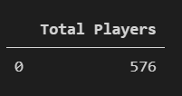

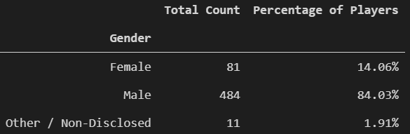

* Our peak age demographic falls between 20-24 (44.8%) with secondary groups falling between 15-19 (18.60%) and 25-29 (13.4%).

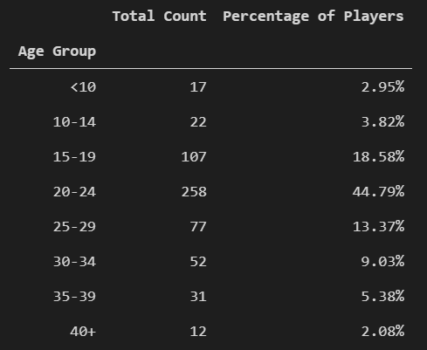

* Our peak age demographic (20-24) is also the highest spender at $1114.06. The second highest total purchase came from the 15-19 group, however, it is less than half of the 20-24 group.
* The players from the 35-39 age group spent the most on the game purchases compared to any other individuals in other age groups

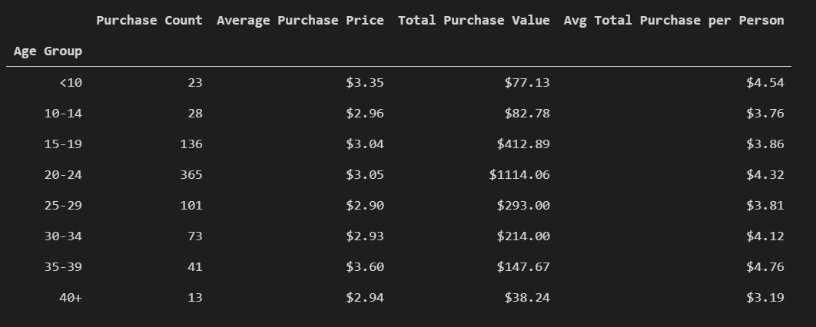

* The most popular game is Final Critic with 13 total purchases. It is also the most profitable with total revenue at $59.99

